(epub)  
Bureaucracies public and private appear to  
be organized [-] so that actors will not be able To perform the tasks as expected.

efficacious p 42 = performatif. ?

paper work is a kind of ritual, but a very boring  
one.

Max Weber and Michel Foucault achieves an intellectual hegemony in USA, 2 reasons

* anti Marx
* attitude Toward bureaucracy, They thought it really works . For Foucault, knowledge is power, shaping minds and bodies Through largely administrative means.

bureaucratic procedures are ways of managing social situations that are already stupid because they are founded on structural violence.

Not abstract. or conceptual violence, but structural. It is enforced by the organization of our societies with a dominant class. but there is no ordinary, actual physical value involved.

Braverman : parcelisation du travail  
le sens du travail vint de la completude des Taichs accomplices

Parkinson's law can refer to either of two observations, published in 1955 by the naval historian C. Northcote Parkinson as an essay in The Economist:[1]

"work expands so as to fill the time available for its completion",

the number of workers within public administration, bureaucracy or officialdom tends to grow, regardless of the amount of work to be done. This was attributed mainly to two factors: that officials want subordinates, not rivals, and that officials make work for each other.

Research consistently shows that the more hours we work, the less productive we become. Need proof? The graph below, put together by The Economist, shows the stark negative correlation between hours worked and productivity per hour in OECD countries between 1990 and 2012

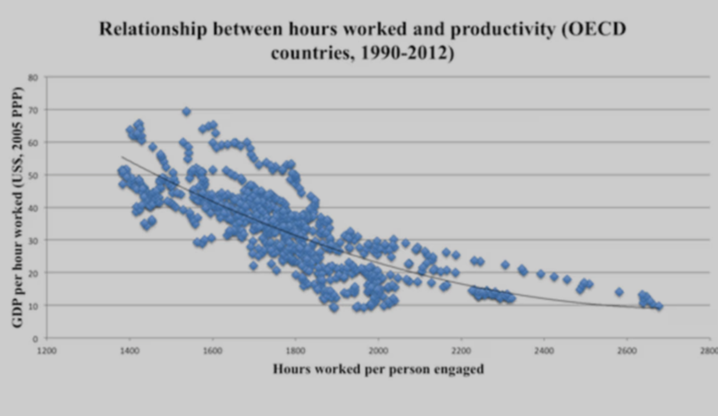

1 Clean up your physical and digital workspace  
2 Review what you have done  
3 Identify the tasks you have avoided and break Them down in smaller sub -tasks  
4 Write out tomorrow's To do list  
5 Eat your frog first (Mark Twain)  
6 Set a Time to end your workday and stick to it  
7 End on a high note  
 Either: forgive yourself  
 : show gratitude  
 Do someone a favour